Nailin Li副教授：瑞典卡罗林斯卡学院介绍及个人研究学术报告

报告题目: Platelets as a coordinator of inflammation and angiogenesis in atherogenesis

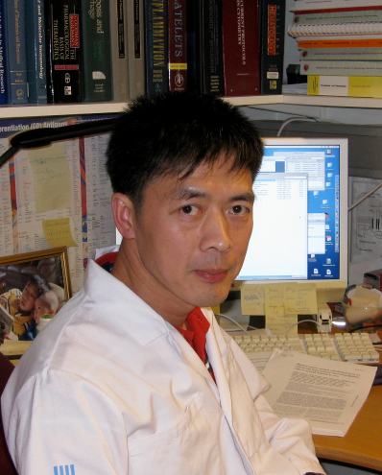
报 告 人：Dr. Nailin Li
Associate professor
Karolinska Institute
报告时间：2013年6月18日下午14:00-15:00
报告地点：医学院综合楼701会议室

卡罗林斯卡学院(Karolinska Institute）是瑞典著名的医学院, 排名世界第七的医学院,世界瞩目的诺贝尔生理学或医学奖的评审地、诞生地。学校位于瑞典北部斯德哥尔摩。卡罗林斯卡学院是欧洲一流的医科大学，以国际领先的科研水平和评审颁发诺贝尔生理学或医学奖闻名于世。学院的核心任务是“致力于通过研究、教育和信息共享来全面提高人类的健康水平”。在追求卓越的过程中，卡罗林斯卡学院将博士生培养和医学科研工作紧密结合；对全体博士生提供强有力的研究生资助体系。卡罗林斯卡学院顺应时代调整自身的的重点学科发展战略，着重于：临床流行病、组织生物学、医学遗传学、生化、干细胞生物学、细菌生物学、医学统计、医学教学法、细胞生物、apop－tosis、细胞分化调节、细胞治疗等。
Nailin Li had his medical education and basic research training at the First Military Medical University (currently Southern Medical University) in Guangzhou. He received his medical degree in 1986 and master degree in 1989. He moved to and pursued his doctoral education at the Karolinska Institute in Stockholm, Sweden in 1995, and had his PhD degree awarded in 1999. After post-doc training in both Karolinska Institute and University of Leicester in UK, he was promoted to associate professor in 2003 and worked as a senior researcher at the Karolinska Institute since then. He has also been appointed as a Karolinska Institute Scientific Coordinator for China to promote research and education collaborations in China.

Dr Li’s main research interests are platelet function, thrombotic and inflammatory mechanisms in atherosclerosis, as well as pre-clinical and clinical evaluation of antiplatelet drugs. He has published over 50 research papers in peer-reviewed journals, including Circulation, Blood, J Thromb Haemost. He is an internationally recognized researcher in platelet functional studies and platelet-T cell interactions. Dr Li currently serves as an editorial broad member of Platelets and as a reviewer for a number of journals in his research field, including JACC, Blood, ATVB, J Thromb Haemost.

